-Testing the effectiveness of Bulletproof Vest-
Defense Industry Information Report

Date: 2020. 12. 07 | Business Center: Vientiane KBC

□ Main Content

ㅇ The Department of Military Science and History organized the first testing of two bulletproof vests which they were able to produce: the K45 pistol bulletproof vest which can protect almost all types of pistols and the AK-47 long steel bulletproof vest.
< Related photo/image>
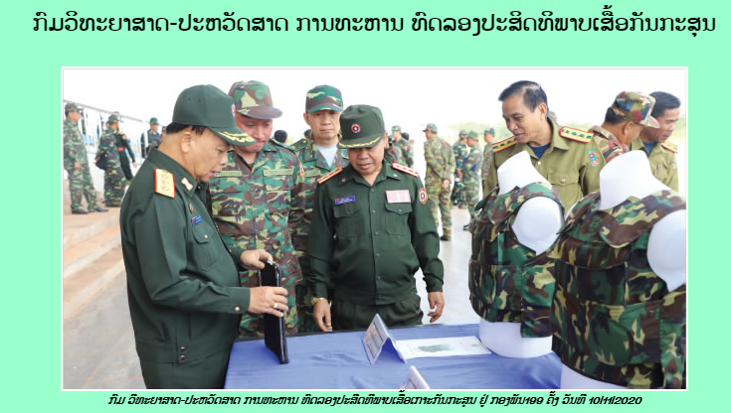

□ Review Opinion

ㅇ This document will be useful for the anti-riot, bulletproof equipment and materials
ㅇ Working closely with Department of Military Science and History for product research and development.
ㅇ Warehouse management for product maintenance and storage.

□ Reference

ㅇ Reference : Army Newspaper / http://mod.gov.la/11112020.php / Published date : 20.11.11

