-Robot Detector under the vehicle-
Defense Industry Information Report

Date: 2020. 12. 07 | Business Center: Vientiane KBC

□ Main Content

ㅇ On the meeting of 2020 summary and stragtegy plan of 2021, Department of Military Science and history is working on the research and development of robot detector under the vehicle.
< Related photo/image>
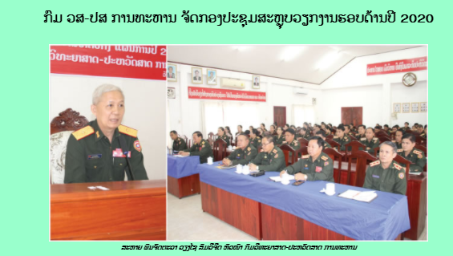

□ Review Opinion

ㅇ Laos is the developing country which before we are the landlock country now the government working on changing to be land link country in the future. So, we need technology to make work more easier and safer than before, as we will be the land link for others countries come and goes. So, this project will suitable for IT security product and system, Training Center for whom interested to be the programmer with international certificate.

□ Reference

ㅇ Reference : Army Newspaper / http://mod.gov.la/02112020_1.php / Published date : 20.10.29

