-220 sets of Telecommunication supported by Ministry of Vietnam National Defense- Defense Industry Information Report

Date: 2020. 12. 07 | Business Center: Vientiane KBC

□ Main Content

ㅇ Ministry of Vietnam National Defense have supported 220 sets of Telecommunication from Telecommunication Industry of Vietnames Army Group (VietTel Group) to Ministry of Laos National Defense at Telecommunication Department.
< Related photo/image>
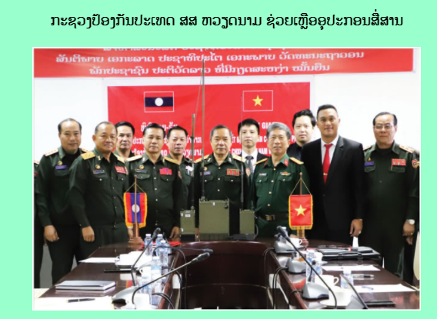

□ Review Opinion

ㅇ The product got supported from Vietnam Minitry of National Defense but Laos Ministry of National Defense still need storage and maintenance management.

□ Reference

ㅇ Reference : Army Newspaper / http://mod.gov.la/19102020.php / Published date : 20.10.19

