-3 Wheels Electric Vehicle-
Defense Industry Information Report

Date: 2020. 12. 07 | Business Center: Vientiane KBC

□ Main Content

ㅇ On the 3th quarterly meeting of Military Science and History Department, they have plan to working on research and develop of 3 wheels electric vehicles for the Department of Policy Office Basic Construction to donate to 598 Handicapped Centre at Luangprabang province.
< Related photo/image>
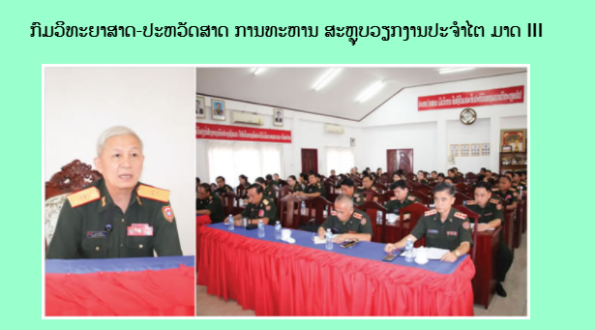

□ Review Opinion

ㅇRenewable energy is the priority strategic for all countries in the world including developing country like Laos. Electric Vehicle is one of the projects that its ongoing research and development so we still need many things as parts, charger area.

□ Reference

ㅇ Reference : Army Newspaper / http://mod.gov.la/15092020_1.php / Published date : 20.09.11

