-Air Guns Prevent installment, testing of ZU23-2 on combat truck ZIL 131 and modification of CQ Guns on AK56-1–
Defense Industry Information Report

Date: 2020. 12. 07 | Business Center: Vientiane KBC

□ Main Content

ㅇ Following the direction of minister of promotion on self-reliance, self-sufficiency and self-empowerment. Department of Army Technical coordinated with the relevant parties to do research and development combat equipment. The first start is air guns prevent model ZU23-2 testing shoot which installment on combat truck model ZIL 131 and also do modification of CQ guns on AK56-1.
< Related photo/image>
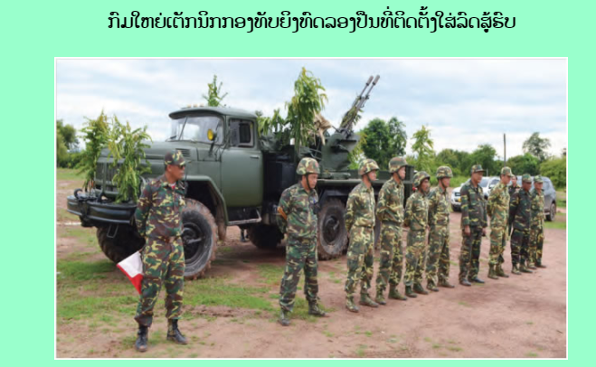

□ Review Opinion

ㅇ This will be benefit to the armored, military vehicle, and ammunitions company who can meet the demand of the Ministry of National Defense.
ㅇ Parts & Components for military vehicle, training equipment and solution for shooting practice

□ Reference

ㅇ Reference : Army Newspaper / http://mod.gov.la/23092020.php / Published date : 20.09.18

