- Air Prevention Factory 674 visited by Military Technical Department -
Defense Industry Information Report

Date : 2021. 01. 06 | Business Center: Vientiane KBC

□ Main Content

ㅇ On Dec 23th, 2020 Deputy Director of Military Technical Department with Air Prevention Department and Weapon-Bullet Management Department are comes to visit Air Prevention Factory 674 for the purpose for this time visit are Air Gun Prevention technical check up and education course to build up the technician for Air Gun Prevention
< Related photo/image>
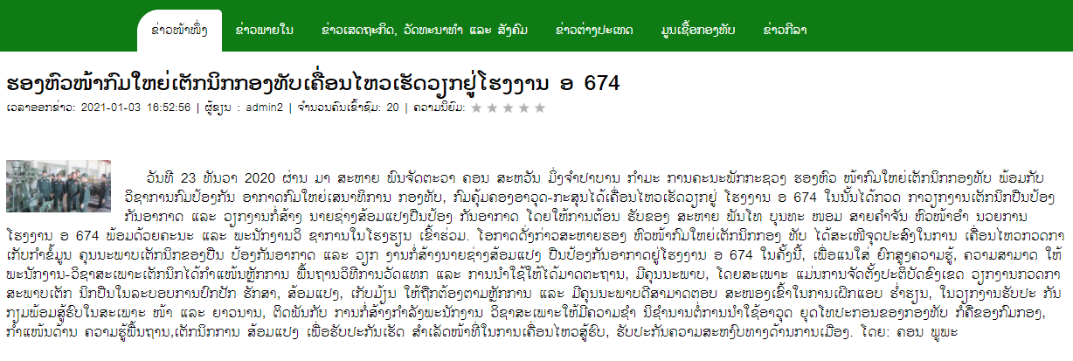

□ Review Opinion

ㅇ For Warehouse management to keep product quality and ready to use.
ㅇ For Training equipment and system that the technician can repeat the course often to improve their skill and have the record to see the improvement.

□ Reference

ㅇ Reference : Kongthap News / https://www.kongthap.gov.la/?lang=lo&at=at&hide=none&page=48&fullnews=7881&ct=25&16=active1 / Published date : 21.01.03

