- Cruiser Hand Over from Border Department to Military Department of Savannakhet province-
Defense Industry Information Report

Date : 2021. 01. 06 | Business Center: Vientiane KBC

□ Main Content

ㅇ On Dec 24th, 2020 Deputy Director and team from Border Department made 5 Cruisers Hand Over from Border Department to Military Department of Savannakhet province
< Related photo/image>
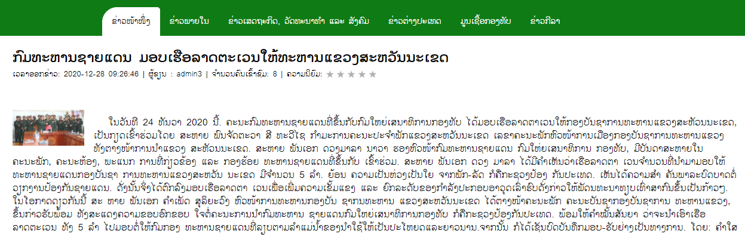

□ Review Opinion

ㅇ For company that provide cruisers or ship spare part and service support for maintenance

□ Reference

ㅇ Reference : Kongthap News / https://www.kongthap.gov.la/?lang=lo&at=at&hide=none&page=48&fullnews=7833&ct=8&09=active1
ㅇ Published date: 20.12.28

