- United states Hands Over Ambulances to Ministry of National Defense -
Defense Industry Information Report

Date : 2020. 12. 22 | Business Center: Vientiane KBC

□ Main Content

ㅇ On October, 1st in a ceremony highlighting growing Lao-U.S. security assistance cooperation, U.S Ambassador handed over nine Ford Everest field ambulances to Deputy Minister of National Defense
< Related photo/image>
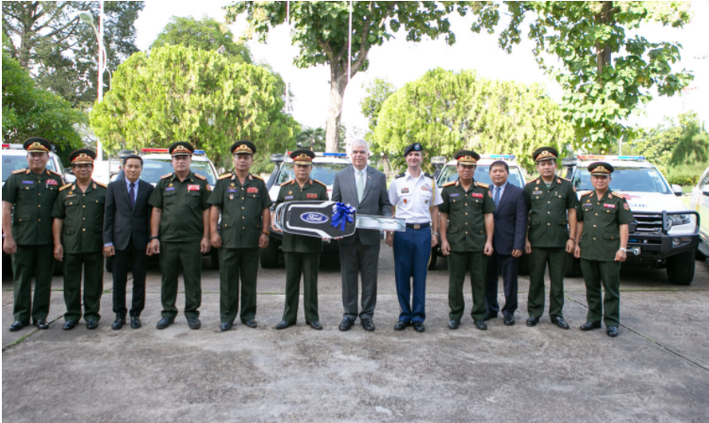

□ Review Opinion
ㅇ This information will be good for pharmaceutical company which provide the medical device especially for the device that can be used in ambulance.
ㅇ For detective product for disaster situation.

□ Reference
ㅇ Reference : U.S. Embassy in Laos / https://la.usembassy.gov/united-states-hands-over-ambulances-to-ministry-of-national-defense / Published date : 20.10.04

