- Work field of Communication Department of Ministry of Public Security -
Defense Industry Information Report

Date : 2020. 12. 24 | Business Center: Vientiane KBC

□ Main Content

ㅇ On Dec 3rd from Newspaper of Ministry of Public Security (MoPS). In 2021, Communication Department have plan to use IT solution system to help for internal work of all department and have plan to request budget for CCTV update in Vientiane Capital 128 points and Luangphabang province 100 points.
< Related photo/image>
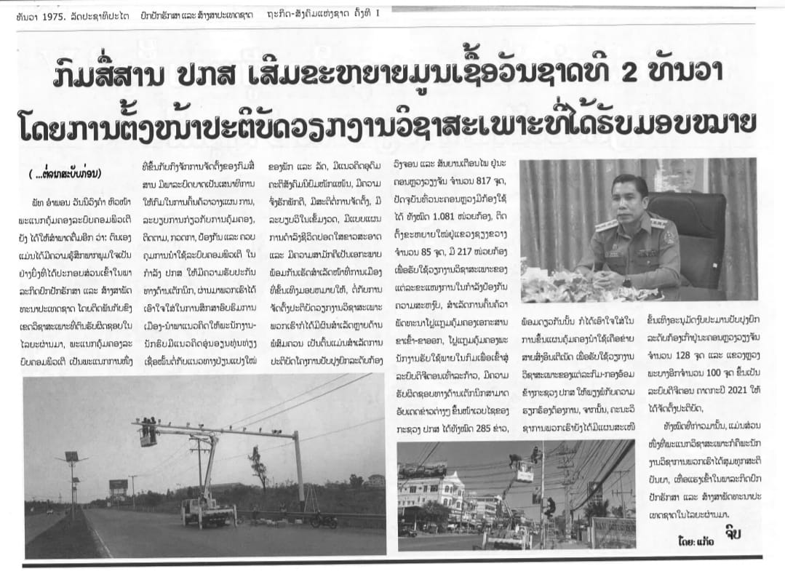

□ Review Opinion
ㅇ For IT solution company that can provide of data management.
ㅇ Security product and system especially CCTV and investigation.

□ Reference
ㅇ Reference : MoPS Newspaper
ㅇ Published date : 20.12.03

