- MOU of Feasibility study-Road construction and Military camp related with Agriculture Development area -
- Defense Industry Information Report -

Date : 2021. 03. 31 | Business Center: Vientiane KBC

□ Main Content
ㅇ On Mar 04th, 2021. At Ministry of National Defense meeting room, MOU sign ceremony of Feasibility study-Road construction and Military camp related with Agriculture Development area at Mounlapamok District, Champasak Province between Ministry of National Defense with Asia Invest-Development and Construction Co., Ltd, In the land 58.296 hectas which they will work on feasibility study in total for 3 years.
< Related photo/image>
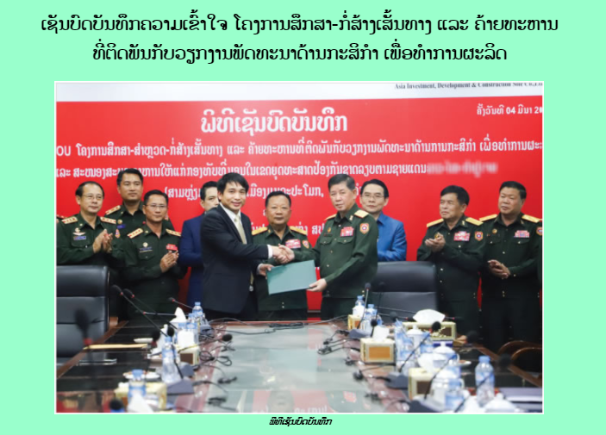

□ Review Opinion
ㅇ AIDC is a leading defense company in Laos and is a highly intimate company with the Laos Ministry of National Defense. It seems necessary to take a close look at its sales activities when preparing to enter the defense industry in Laos.
ㅇ Opportunity for the company that interested to join project for feasibility study on first infrastructure, agriculture area with Asia Invest-Development and Construction Co., Ltd.

□ Reference
ㅇ Reference : Army Newspaper / https://www.mod.gov.la/05032021.php
ㅇ Published date : 2021.03.04

