- Manufacture and quality certificate of metals and gun ring of 122 D30, 152 D20, 85 D44, 130 M44
- Defense Industry Information Report -

Date : 2021. 03. 31 | Business Center: Vientiane KBC

□ Main Content
ㅇ On summary work of 2020 meeting from Industrial Department of Ministry of National Defense, Director of Planing Section of Industrial Department was reported for 2020 work which they have manufacture to produce gun ring of 122 D30, 152 D20, 85D44, 130 M44 and they are working on quality certificate of metal for manufacture.
< Related photo/image>
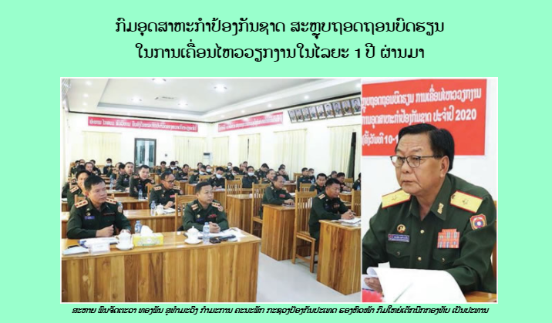

□ Review Opinion
ㅇ Opportunity for the company that can provide the raw materials for manufacture to produce equipment to use to reduce the cost of finish product import.
□ Reference
ㅇ Reference : Army Newspaper / https://www.mod.gov.la/16032021.php
ㅇ Published date : 2021.03.11

